# Mobile Automation Exercise

Aravindh S Chandrasekaran - Senior System Engineer

**Contact No: +91-9600044057**  **Current Location: Chennai/MCity Email id:** [**aravindh.c@infosys.com**](mailto:aravindh.c@infosys.com)

**Employee Number: 744068**

**Role Designation and Job Level: SSE/JL3**

Develop a mobile testing solution that automates a few simple tests, composed as BDD scenarios.

The target for the test is the Android app OI Shopping list, details can be found here: http://www.openintents.org/shoppinglist/

Test Automation Suite Description:

*A Maven based project integrated with cucumber(BDD driven framework) has been created with all the required dependencies. Appium tool is used to automate the “Shopping List” app in mobile device. The project structure consists of the following files.*

1. *1 Page Locator file(PageLocators.java) is created as the framework based on Page Object Model(POM).*
2. *1 Step Definition file (ShoppingStepDef.java)*
3. *1 feature file (AddingList.feature)*
4. *1 Test runner file (TestRunner.java)*
5. *1 Java file (HomePage.java)*

*A feature file has been created with 2 scenarios based on the scenarios given below. Test Runner file is created to glue the feature file with the step definition file. Step definition file calls the respective method which has the business logic based on the scenarios.*

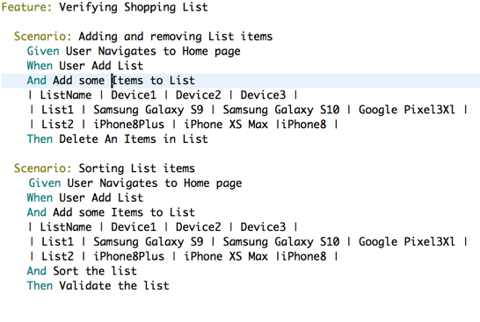

Scenario 1:

* Create 2 new lists – *A method addList () is used to create a list in the Shopping list app.*
* Add new list items – *A method addItems () is used to add items to the created list. Items are passed* *using Data Table, which helps in creating the items dynamically.*
* Delete an item from the list – *A method deleteItems () is used to delete an item from the list.*

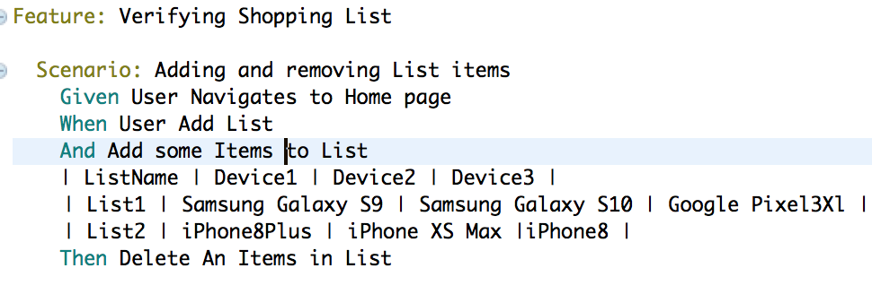

## Scenario 2:

* Create a list and add items- *Methods addList () and addItems() are re-used to create list and add items to the list.*
* Sort the list and validate the sorting of the list items- *Methods sortList () is created to select a list which consists of list of mobile devices in it and sort the items in it based on alphabetical order. Then ValidateList() is created which stores the items created in a list and validate whether the lists are sorted in alphabetical order.*

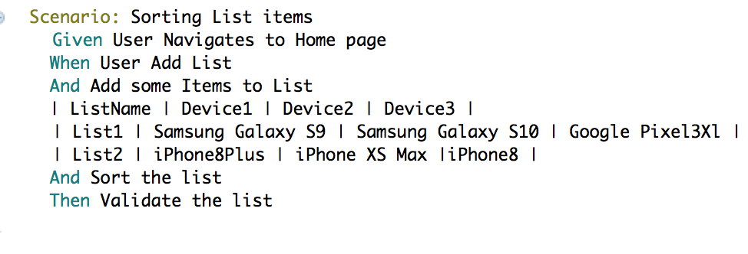

## Candidate Requirements:

a. Build a test project that includes automation of the 2 scenario above. *Scenario Adding and removing List items and Sorting List items are created in feature file.*

b. Solution to be coded in Java and driven using a BDD tool (see potential solution components below)

c. Share code in a public GitHub repository for review. Include execution instructions.

d. Share further improvements that could be considered to develop the framework (Optional).

Potential Solution Components: *A simple framework which follows Page Object Model mechanism is created with Page locators stored as a separate file. Complete reusability of code is achieved for automating the application.*

## Suggested Toolset

The following suggested tools and libraries (or similar substitutes) should be used:

Appium

CucumberJVM

Maven